**Culture and safety in Douala: the cases of New Bell and Bessengue**

**Marta Pucciarelli**

Douala is a chaotic metropolis of the Sub-Saharan Africa faced to the Atlantic Ocean habited by three million of people. It is the economic and most developed city of Cameroun, in continuous horizontal expansion, formally divided in six administrative districts including a total of 118 neighborhoods. With the exception of few prestigious neighborhoods[1], Douala is characterized by a lack of public services (like regular electivity, access to water, sewers, and paved roads), the presence of informal settlements, widespread poverty and diffused unemployment (Loe & Meutchehé Ngomsi, 2004). This situation generates a complex urban landscape, in which since the last twenty years a new contemporary cultural sector has flourished, making of the city a stage of art festivals, workshops, trainings, as well as ephemeral and permanent art installations addressed to the local public (Babina & Bell, 2008; Diwota-Kotto & Manga, 2011; ICU, 2012).

According to Marilyn Douala Bell[2], president of doual’art, a local contemporary art center working and funding public art into the city, permanent art installations can be classified as follows:

1. Monumental installations: large scale sculptures generally positioned in traffic places.
2. Passageways artworks: murals and small scales sculptures positioned along the roads of poor neighborhoods.
3. Proximity artworks: architectural installations with very specific functions located closed to living spaces of marginalized neighborhoods.

Based on this classification, an ethnographic study has been conducted from December 2012 to January 2013 with the aim to explore the impact of permanent art installations on safety and security. The research has been circumscribed on New Bell and Bessengue, two popular and central neighborhoods of the city hosting the three types of public art. In New Bell[3], the study has been concentrated in two areas: 1) around the monumental *Colonne Pascal* (Fig. 1) of Pascal Marthine Tayou (2010), a twelve meters installation made of enamel pots superimposed in the heart of the very busy roundabout Shell New Bell; and 2) within the Ngangue neighborhood, hosting *Les Mots Écrits de New Bell* (Fig. 2) of Hervé Yamguen (2010), a series of five mural installations. In Bessengue, the investigation focused on the impact of two proximity artworks: 1) the *Borne-Fontaine* of Bessengue (Fig. 3) of Danielle Diwouta-Kotto (2003), a fountain kiosk built around a frame structure and steel beams covered with an inverted sloping roof which recalls the shape of a butterfly's wings; and (2) *La Passerelle de Bessengue*, (Fig. 4) a wooden bridge with iron handrails representing people of different ethnic groups holding hands, designed by the artist Alioum Moussa (2005).

**New Bell**

New Bell is the typical *kwatt* of Douala, where « you’re going to walk and fall down in the mud, you're going to cross dirty rivulets to go in the sub district, you're going to enter people's homes to go to your»[4]. It is distant only one kilometer from the administrative and commercial center of the city but, differently from them, since the independence it has been massively and spontaneously occupied by immigrant population moved to Douala in search of work (Schler, 2008). From a safety perspective, New Bell is marked by a serious unhealthy environment depending by the lack of sewers, garbage collection and the regular provision of running water. At the same time, the scarcity of public enlightenment, the diffuse poverty and unemployment often drive people to commit thefts and aggressions, addressing the district a very dangerous reputation (Loe & Meutchehé Ngomsi, 2004). This negative image seems to be often exaggerated and stereotyped by two main factors: first of all, for its long history of immigration and welcoming attitude toward foreign immigrants, in particular Nigerian, Malian and Ivory Coast communities (Njoh, 2007); and secondly, for hosting the jail of the city with the consequent popular fear that criminals could escape and hidden into the district (Loe, Meutchehé Ngomsi, & Nken Hibock, 2007). As a response to this bad reputation, inhabitants have strengthen a fair sense of belonging to New Bell, which allow them to feel unique and perfectly recognizable from all others dwellers of Douala, for their way of being, of moving, of talking, and enjoying life. Their relationship with cultural activities and public artworks usually depends from the grade to which they have been involved into the process of production and the location of the installation.

**Monumental installations: the case ofLa Colonne Pascal**

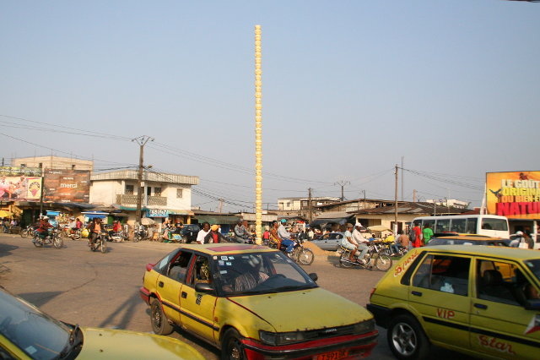

Figure La Colonne Pascal (Pascal Marthine Tayou, 2010)

Monumental installations in Douala are the most criticized and controversial types of public artworks. The high visibility of these installations, generally located at the intersection of busy roundabouts or crossroads, calls into questions judgments and opinions of several local actors, including inhabitants, media and public authorities (Malaquais, 2006). The materialization and magnification of a singular piece of reality chosen and represented by a unique artist makes inhabitants feel excluded from a discussion that mainly concern them (or their lands). During the process of production, indeed, the negotiation on the artwork happens between the funding agency (doual’art) and the artists, without getting local community’s voices included in the artwork conceptualization and development. From inhabitant’s point of view, this direct flux of decision-making can be perceived as imposed, and often it becomes occasion to raise cultural and historical disputes as a response of popular discontents and negative attitudes toward the installation. Differently, the presence of monuments attracts local medias, which contribute at improving the image of the place, at discussing about aesthetical changes into the districts, and at generating new visual landmarks at urban level. Finally, the places of monuments receive significant attention also from public authorities, in terms of investment and service provision.

The case of the Colonne Pascal is representative of this public response. There are two main critics given by inhabitants who do not appreciate the installation (36%). The first one, strongly supported by the traditional chief of the neighborhood, accuses the installation to be unrespectable of the memory of the place: «this (the Colonne Pascal) does not reflect the history of the area. We should build a monument to present our children as well as our grandchildren»[5]. The reasons can be related to the riots of May 1955, preceding the independence of Cameroun, during which around one thousand of people died (as recalled by *Avenue de l’Indipendance*, the main road crossing the square). A second critic moved by inhabitants on the Colonne Pascal, considers the installation as «the evidence that New Bell’s inhabitants have the hungry belly»[6]. This interpretation is generally associated with a refuse to be identified with poverty. At the same time, more than half of the population declares to appreciate the installation attributing it a sense of requalification of the public space (20%), of modernity (12%), or even without understanding the meaning (30%). Despite this divergence in the public opinion almost everyone (96%) perceive Shell New Bell as a safe landmark for mobility, but even for dating partners, meeting friends, having lunch or enjoying a beer. The number of informal markets offering bakery products and take away foods has exponentially increased.

Concerning security and criminality issues, 84% of the interviewees report that aggressions are diminished, thanks to a recent established self-defense group and the mutual surveillance of informal traders. Despite those declarations, a significant number of people (64%) suggest that during the night and the first hours of the morning, when the place is empty, their perceived level of security strongly decreases. Based on locals’ statements, the reputation of the area is improved, and also tourists are increased even if their presence is not regular. This can be related to the resounding media attention given to the Colonne Pascal by newspaper, newscasts, and TV series for representing the entire district.

This improvement in reputation has also fostered public authorities for taking some measures to fight the disorder: first of all, bins have been located on the sides of the roundabout and the state-controlled company in service to collect garbage (HYSACAM) passes from there every morning. Secondly, the police have increased the frequency of patrols accessing the area, even if interviewees demand for regularity and efficiency of their interventions.

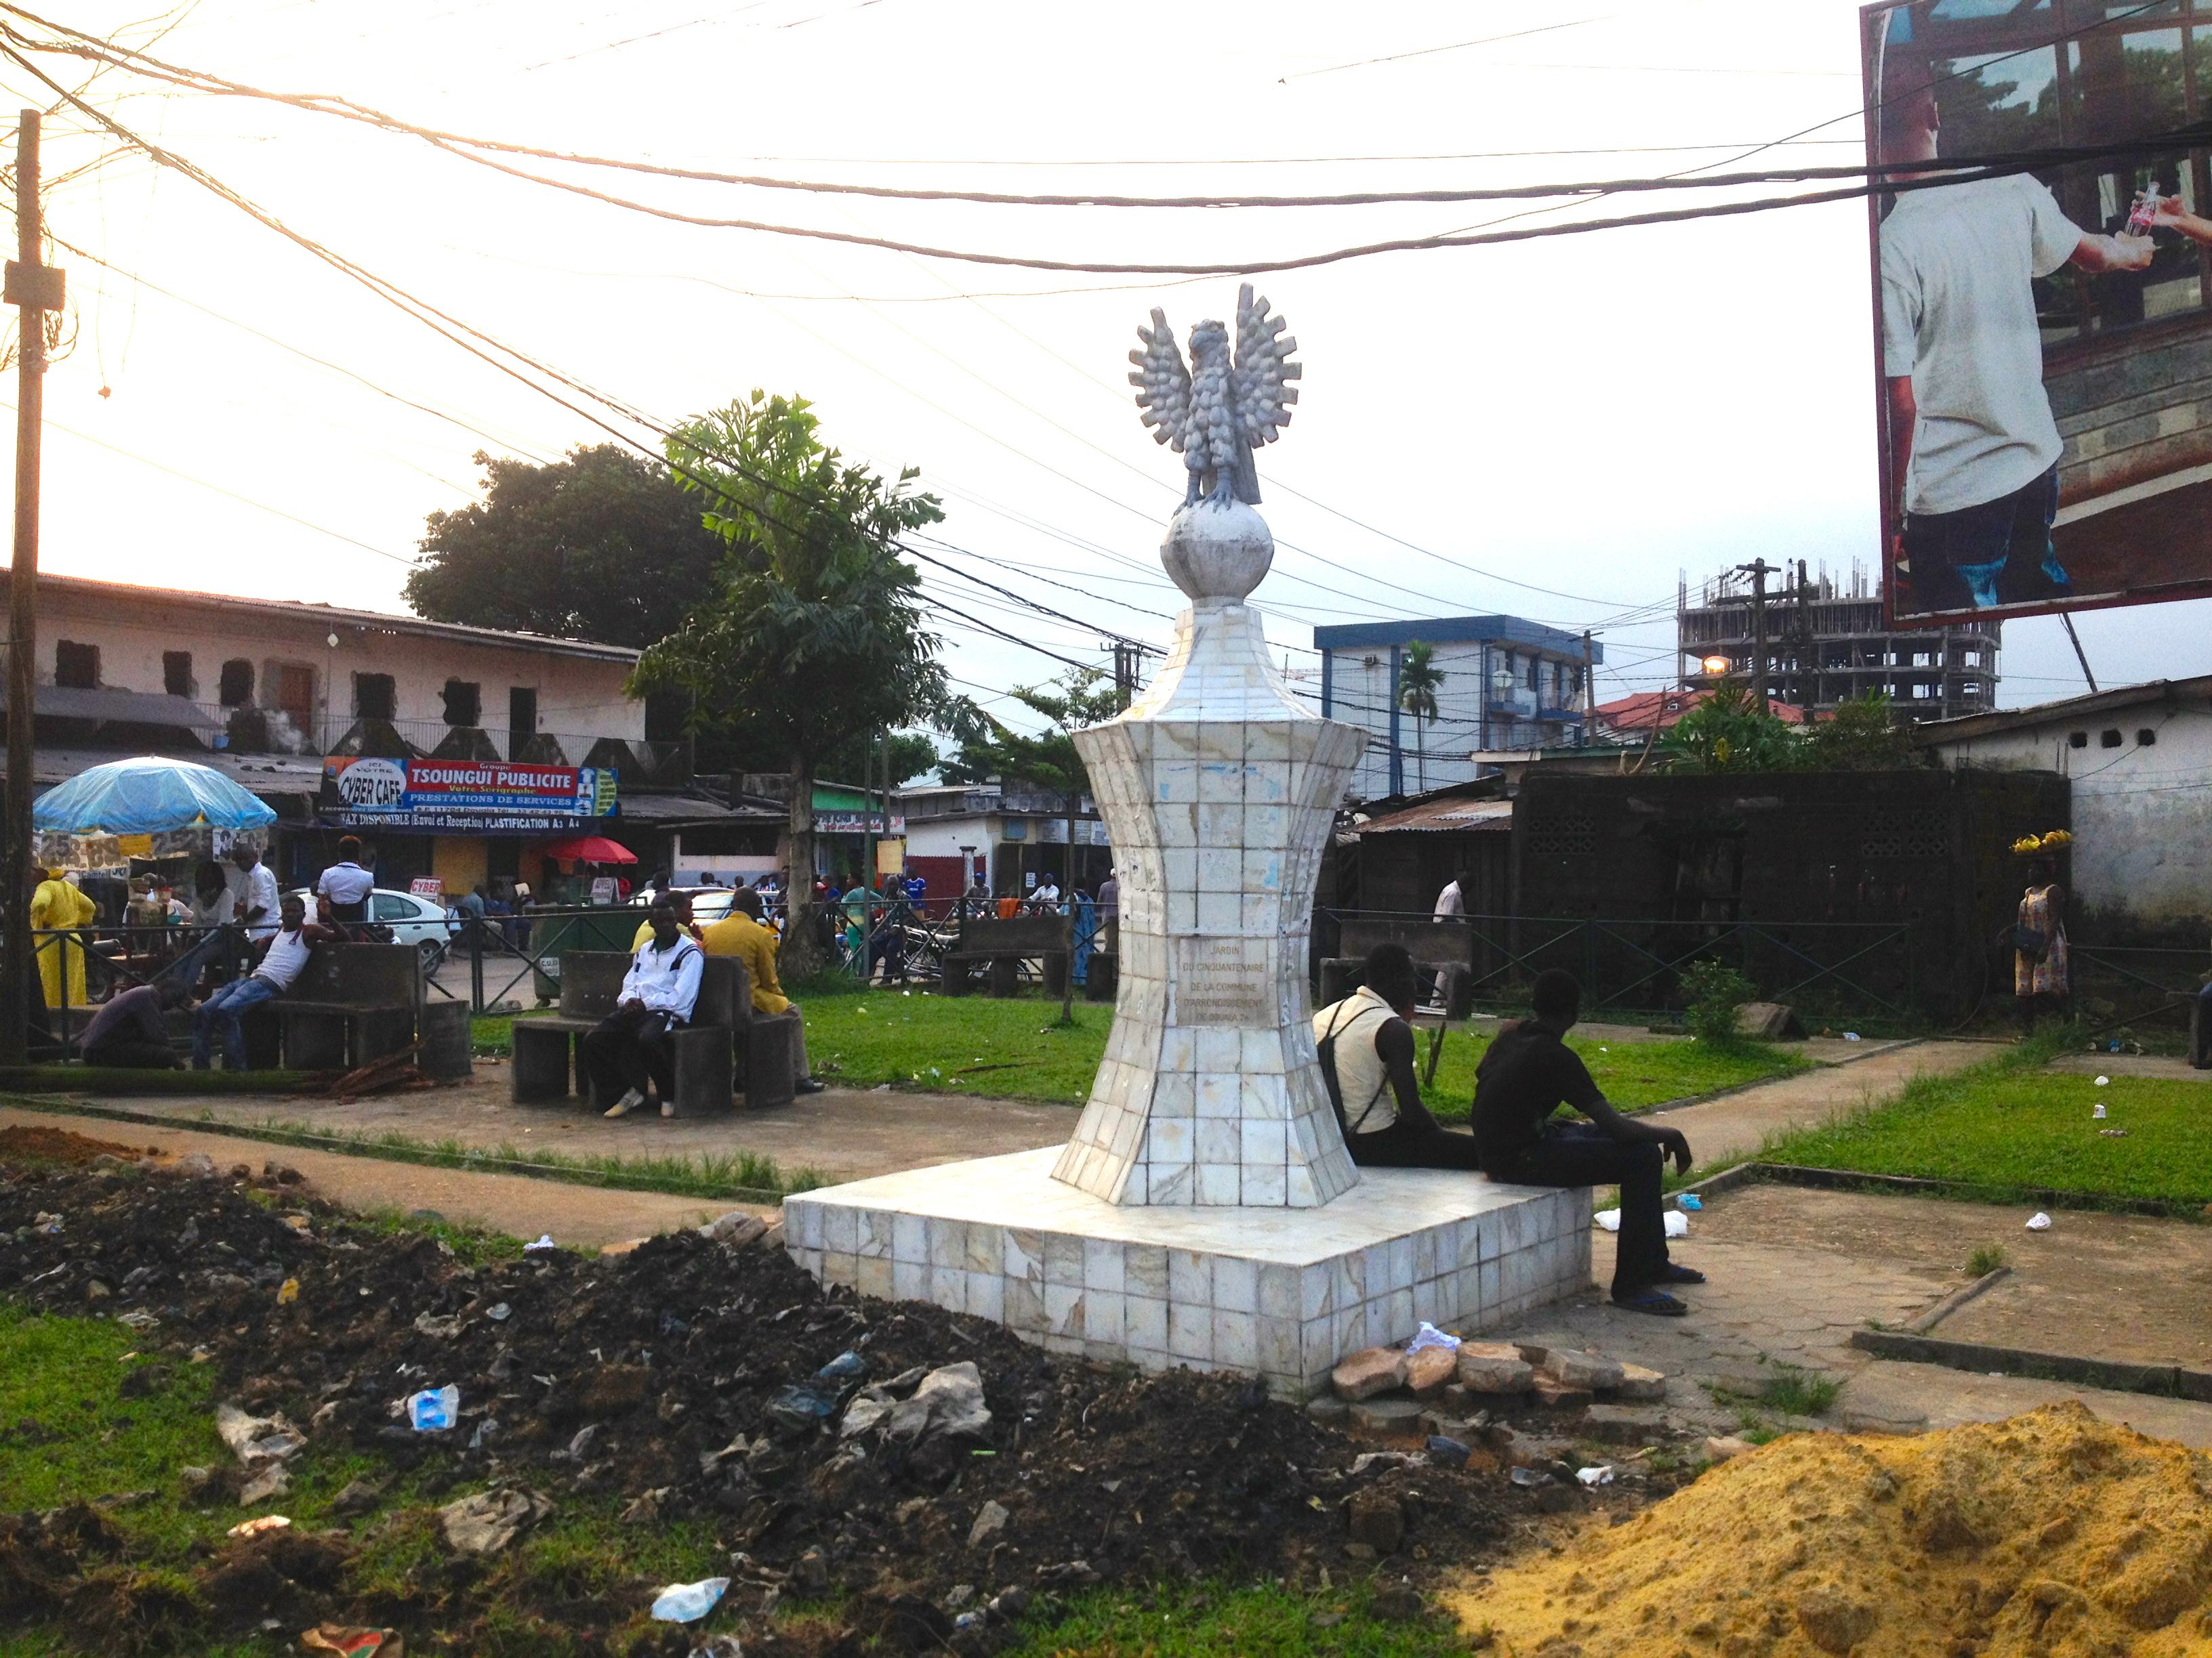

Figure 2: Monument de l'aigle (CUD, 2010)

Finally, just in front to the Colonne Pascal, the Urban Community of Douala has funded and created (in the same year of the Tayou’s installation) a small green area furnished with some benches and lights, reinforcing the sense of the zone as meeting place, and with a white tiled monument having an eagle at the top of it (Fig.5).

**Passageways installation: the case of *Les Mots Écrits de New Bell***

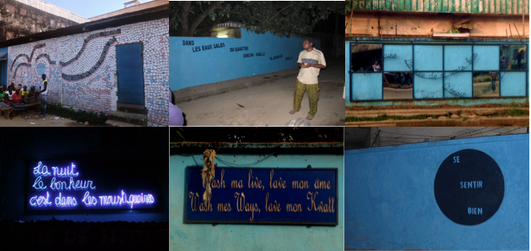

Figure 3 Les Mots Écrits de New Bell (Hervé Yamguen, 2010)

The impact of artworks positioned in passageways, is completely different from monumental installations, and certainly it is more absorbed in the ordinary life of inhabitants. In New Bell Ngangue, people are pleased to host public art and their presence is totally (100%) accepted, appreciated and interrogated. A spread enthusiasm towards the installations emerges from interviews and questionnaires, and it seems to be strictly related to people’s feeling of inclusion and participation to the art production process. This may depend by the fact that the artist Hervé Yamguen is living and working into the neighborhood and he is widely known and respected by the community. For the Mots Écrits de New Bell, he directly involved three local rappers in the record production of songs, from which Yamguen has extrapolated the sentences that nowadays appears on the wall of the neighborhood. Additionally, during all the production process, dwellers were introduced to the project through performances, ephemeral events, and meetings, creating unusual opportunities for debates on artistic and social issues. When it came to decide the location of installations, inhabitants decided to donate the façades of their houses (or their commercial activities) for hosting public art installations, at the point that inhabitants’ offers surpassed the demand of locations by the artist.

After two years of their production, Ngangue’s dwellers report that public art has an educative role toward the society and it contribute to make «shine the neighborhood»[7]. The sentences of Mots Écrits de New Bell reveal concerns and expectations of New Bell’s young generation, and they are interpreted as «another vision of our realities as shout of alarm»[8]. They foster people self-esteem toward their neighborhood, contributing to improve its image within the city, by publically showing «the originality of a district judged as wild»[9], and opening new possibilities toward modernity, progress, and renaissance of public spaces. At the same time, as declared by a schoolteacher, public art «awakes. It awakens great people as it awakes children. Pupils also took leaves in classrooms. They made drawings. Actually, it was like a competition»[10]. Beside the imitation of children, within the neighborhood is possible to notice the facades of some houses reproducing similar drawing to the wall of Hervé Yamguen’s habitation. At individual level, the presence of art installation has stimulated inhabitants to take care of their private and public surrounded environment. Some evidences include the introduction of plants and flowers outside informal settlements located around the installations, as well as panels forbidding people to through garbage on the ground. The owner of «La joie de Njongmabi», the bar hosting the blue neon, affirms to renew the facade of his bar every year. In 2010, he accepted to pay for electricity on his own, in order to ensure the visibility of the artwork. After two years he had improved and enlarged the surface of his bar, by tiling the floor and changing old wood tables, with plastic one, more practical to move and to clean. Compared with other clubs of the neighborhoods, the Joie de Njongmabi is now considered a safe landmark also from young and women, even during the night, when in Ngangue the security level is not guaranteed.

Another significant example regards the murals of the CBC Babylon School, which have generated an astonished impact in term of reputation, providing the institution with an image of cleanliness, modernity and seriousness. In less than three years, the number of students enrolled has increased from 57 to 400; ten more teachers have been employed; a new block have been built; and the pedagogical offer has been extended, offering a bilingual curriculum. The school is now visited by tourists, who access to take photos and ask for information, but also by locals coming from the near sub-districts, who are attracted by curiosity and desire to enroll their children.

Despite those artworks formally belong to the local authority, i.e. the Urban Community of Douala (CUD), the public intervention on this neighborhood until now has been limited to the introduction of few bins along the main paved road of the neighborhood, even if their collection is not always regular. Two cultural and security issues still remain opened. The first one regards the maintenance of artworks and wall paints that after few years require to be restored. In particular there are two of the Mots Écrits de New Bell that have been seriously damaged by water, in one case, and by vandals in the other. The second one concerns the implementation of security measures to respond local community requests. Since September 2012, indeed, Ngangue’s dwellers driven by the artist Hervé Yamguen, have started a petition against public disorder, aggressions, violence and prostitutions which perpetuate around two main bars of the neighborhood: “Prolongation” et “Exclusive dream”. They have hanged banners along the neighborhood for intimidating *bandits* to do not enter or they would have put their life in danger. Until December 2013 inhabitants’ demands to support to the CUD has not yet been considered.

**Bessengue**

Bessengue is a small and overcrowded stretch of informal settlements, enclosed in a wedged valley between two watercourses: the Mbopi and Nguété rivers and two main streets: the *Boulevard de la République* and the *Boulevard de l’Unité*. This position is particularly disadvantaged during rainy seasons when regular floods increase the risk of the neighborhood to remains obstructed by its borders (The World Bank, 2010). Two main ethnic groups populate Bessengue: the Bamoun, emigrated from the North-West of Cameroun, and the native Duala. Until now, Bamoun and Duala are struggling to live peacefully, due to historical reasons related to the urbanization process of the area. The current disputes between the two ethnic groups depend by the fact that the native Duala accuses the halogens Bamoun to have denigrated their lands, making them unhealthy and taking welfare away from others.

**Proximity artworks: the cases of *La Passerelle* and *La Borne-Fontaine de Bessengue***

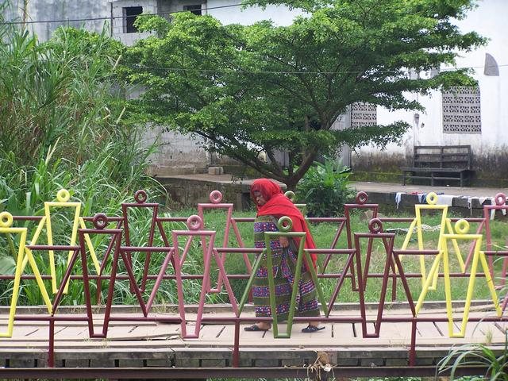 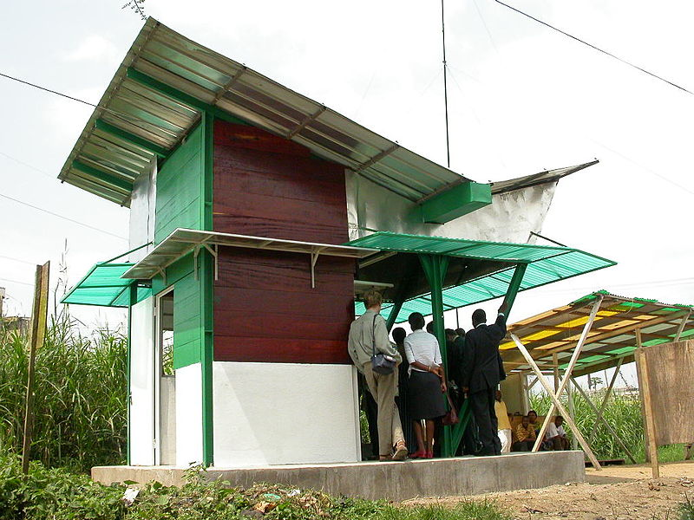

Figure 4 La Passerelle de Bessengue (A. Moussa, 2005) Figure 5 Borne-Fontaine de Bessengue (D. Diwota-Kotto, 2003)

Bessengue is the first district in which proximity artworks have been produced. Since 2003 the process of art production of this type of installation has been refined and improved, involving also foreigner artists in residences programs to directly negotiate with the community their public art concepts.

However, in the specific case of Bessengue, the process have been slightly different: after a long negotiation between doual’art and the community, the concepts of the Passerelle and the Borne-Fontaine were defined, and local communities selected the prototypes which better represent their ideals. This strong commitment of inhabitants is used to generate art installations that embedded very specific utilitarian features.

After ten years of the Passerelle and the Borne-Fontaine production, only 12% of the population recognizes these installations as artworks. When inhabitants were demanded about their meaning three main words come out: aid, development and utility – in accessing water and facilitating the circulation of people and vehicles. People’s feelings of social exclusion have strongly decreased: they explicitly affirm that the *Passerelle* and the *Borne-Fontaine* are the demonstration that someone has finally noticed (and improved) their previously austere situation. Almost all interviewees (98%), indeed, are proud of those installations, also because now they can «be protected from the cholera»[11] and «live in a more pleasant, coloured environment»[12]. Two persons, talking about the bridge, have indicated that the handrails produced by Alioum Moussa means the peaceful collaboration between Bamoun and Douala ethic groups.

The process of production of the *Borne-Fontaine* and *La Passerelle* has generated not only advantages in term of facilities, but also social cohesion and responsibility. After a first involvement in the definition of the Borne-Fontaine, members of different ethnic groups living into the neighborhood decided to establish a Development Committee (Communoté de Développement de Bessengue-Akwa, CDBA), asking doual’art to be trained on development project management. The work of the CDBA is completely voluntary and they are used to organize a regular meeting to discuss about district improvements. The active engagement of the CDBA has attracted international funds, making of Bessengue a pilot district for development projects supported by the World Bank (UN-HABITAT, 2011). Without CDBA’s presence and actions for improving Bessengue, the participatory strategy of funding agencies would not be possible.

After the implementation of the *Borne-Fontaine* and *La Passerelle*, others two water pumps have been installed into the second and third blocks of the Bessengue. The lanes of the valley have been paved, and a wide patch has been created along the Mbopi River, allowing ambulance and firemen to access the district in case of emergency. As declared by Ndoumbe Ebenezer, the president of the CDBA «before the bridge and before all the pedestrian passageways, it was a landlocked area. That is to say, it was not possible to get around the neighborhood, and people did not have access to the area. And even for the disposal of refuse, bringing them on the road where now you can see the bins, it was not possible. And even taxis couldn’t enter the area in case of an emergency such as illness during the night. And even when there were fires - as we have recently had a fire here - the cars of the firefighters had no access to the area to extinguish the fire».[13]

At the same time the CDBA has also demanded and obtained a certain support from the Urban Community of Douala, in order to drain the bad of the Mbopi River, taking off plastic garbage, for helping the soil to absorb raining waters. This operation has now been guaranteed every two years, allowing the prevention and reduction of the risk of floods and human disaster. Moreover, just out of the district two bins have been placed to collect wasted material. The agency in charge of this service, HYSACAM, passes every day to gut them. These actions have also inducted local communities to take care of their surrounding environment by sweeping streets outside their houses and engaging adolescents for cleaning activities, such as pulling weeds and collecting the dirt.

Finally, the creation of the Passerelle has disclosed the neighborhood to the commercial district of Akwa, and opened a new squared area between the Passerelle and the Borne-Fontaine. This square is become a safe landmark for children’s open-air plays, while women meet there for chatting around the fountain or for doing shopping. In this area new informal business activities have sprouted, or improve their commercial activities, including coffee shops, hair salons, tailoring shops, boutiques (12%), call boxes, restaurants and bakery vendors, counter sales of fruits and vegetables, and informal pharmacies.

**Conclusion**

This chapter describes the impact of monuments, passageways and proximity artworks of Douala on urban safety and security. It can be argued that public art generates positive effects on the urban landscape and local community actions. The impact of public art generally depends by the types of the installation and the negotiation processes between funding agency, artists and local communities. In some cases, the influence of public art on safety and security is more direct, while in other cases it happen more at an individual level rather than a collective one.

Finally, it is important to notice that it is not the mere presence of public artworks that generate safety and security but it is the quality of the production process, the intellectual value of the artwork, and the engagement of local communities, that in Douala trigger social reactions and civic responsibilities of citizens and public authorities.

**References**

Babina, L., & Bell, M. D. (2008). *Douala in Translation: A View of the City and Its Creative Transformative Potentials*. Episode Publishers.

Diwota-Kotto, D., & Manga, L. (2011). Douala: Interviewed Architecture. ArchiAfrica.

ICU, A. P. (2012). *Making Douala 2007-2013*. International Architecture Biennale Rotterdam.

Loe, M. F., & Meutchehé Ngomsi, A. C. (2004). Diagnostic de la delinquance urbaine de Douala. Villes Plus Sûres, UN-HABITAT.

Loe, M. F., Meutchehé Ngomsi, A. C., & Nken Hibock, M. L. (2007). Plan d’Action Strategique de Lutte contre la Delinquance Urbaine à Douala. UN-HABITAT, PNUD, CUD.

Malaquais, D. (2006). Une nouvelle liberté? Art et politique urbaine à Douala (Cameroun). *Afrique & Histoire*, *5*(1), 111–134.

Njoh, A. J. (2007). Planning in the Cameroons and Togoland. In *Planning Power: Town Planning and Social Control in Colonial Africa* (pp. 127–144). Routledge.

Schler, L. (2008). *The Strangers of New Bell: Immigration, Public Space and Community in Colonial Douala, Cameroon, 1914-1960*. UNISA Press.

The World Bank. (2010). *Cameroon - Douala Infrastructure Project* (No. ICR1413) (pp. 1–56). The World Bank. Retrieved from http://documents.worldbank.org/curated/en/2010/06/12674466/cameroon-douala-infrastructure-project

UN-HABITAT. (2011). *Building urban safety through slum upgrading.* Nairobi: UN-HABITAT.

**General references**

On public art

Bertsche, Lisle (2013). Public Art and the Central Corridor: Place Promotion and Creative Placemaking, in *Cities in the 21st Century*, 3(1).

Goldstein, Barbara (2005). *Public Art by the Book*. Americans for the Arts

Diwouta-Kotto, Daniele (2010). *Suites architecturales: Kinshasa, Douala, Dakar*. Edition VAA

On the urban space

Bell, Daniel A., de-Shalit Avner (2013). *The spirit of cities: Why the Identity of a City Matters in a Global Age*. Princeton University Press

Rao, Vyjayanthi, De Boeck Filip, Abdou Maliq Simone. (2009). Urbanism beyond Architecture: African Cities as Infrastructure, in *African Cities Readers* 1(1), 23–40.

Ndjio, Basile, Konings Piet, Foeken Dick. (2006). *Crisis and Creativity: Exploring the Wealth of the African Neighborhood*. Brill Leiden - Boston

Murray, Martin, Myers Garth A. (2007). Cities in Contemporary Africa. Macmillan

1. With prestigious neighborhoods I’m referring to the ones located at the cost site of the city, in particular Bonanjo, Bonapriso, Bali, Akwa, and to the new residential area located at North East of the city, including Bonamoussadi, Kotto, Makepe and Logpom.
2. Personal conversation with Marilyn Douala Bell, president of doual’art, 08/01/2013
3. Formally the city is divided in six administrative districts or *arrondissments*, each one hosting different neighborhoods. New Bell is the arrondissement of Douala II to which belong 32 neighborhoods, including New Bell-Ngangue. Differently, Bessengue is a neighborhood belonging to the arrondissment Douala I (which major headquarter is based in Bonanjo).
4. Personal conversation with Junior Ndalle, journalist living and working in Douala (19/12/2012)
5. Quotation reported from the survey conducted in Shell New Bell on 18 January 2013
6. Quotation reported from the survey conducted in Shell New Bell on 18 January 2013
7. Quotation reported from the survey conducted in New Bell Ngangue on 17 January 2013
8. Quotation reported from the survey conducted in New Bell Ngangue on 17 January 2013
9. Quotation reported from the survey conducted in New Bell Ngangue on 17 January 2013
10. Personal conversation with teacher David from the CBC Babylon school (11/12/2012)
11. Quotation reported from the survey conducted in Bessengue on 16 January 2013
12. Quotation reported from the survey conducted in Bessengue on 16 January 2013
13. Personal conversation with Ndoumbe Ebenezer, President Communoté Developpement Bessengué-Akwa (14/12/2102)